

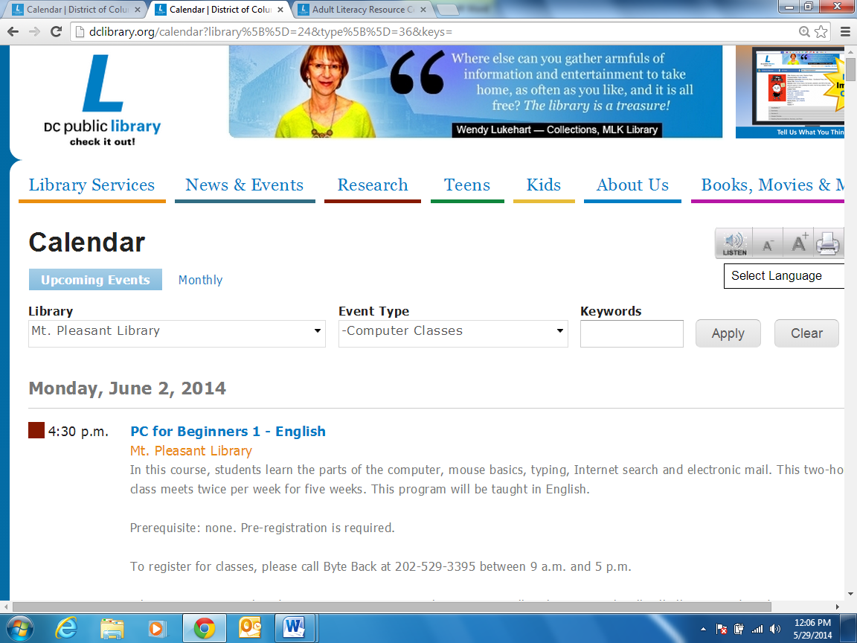
Level 4 DC Library Web Quest

Directions | Put information here/Answers
- Find the DC public library website | Copy/Paste the URL here
- Click on Library Services | Type 3 services here
- Push ctrl key and click on Computer Services. Open this page in a new tab. | Who should you contact if you have a question? What is the phone number?
- Click on Library Calendar. Click on the drop down menu. Select Mt. Pleasant Library. Then click on Computer Classes. Then click “Apply” See picture below. | - What languages are the classes offered in?  - Who do you call to register for a class?
- Go back to the Library Services tab. Push ctrl key and click on Adult Literacy. Open this page in a new tab. | What are 3 types of classes or services that the library offers?
- Click on the Kids tab. Click on Story Time. Click on Calendar. Select Mt. Pleasant Library, Martin Luther King, Jr, Petworth, and Shaw Library. | If you have children or have relatives with children, find a program that would be good them.
- Click on the How Do I…? drop down menu. Click on Get a Library Card. | - Can you get a library card?  - What do you need to get a card?
- Go back to the Library Services tab. Click on Computers and Printing. | - How long can you use library computers?  - How much does it cost to print?
- Go back to the Library Services tab. Click Job Seekers | What are 3 things the pages can help you with?
- Go to http://dclibrary.org/summerreading | Click on Literacy Elements. How can you participate? What can you win?
- Explore the rest of the website. Click on whatever interests you. | What did you learn?
- Save this document and e-mail it to arozzo@carlosrosario.org | Done

4.

